Requirements Analysis Document

COMP596 - Spring 2008

Best Of Both Worlds

Team Members:

Troy Burney

Donovan Reese

Faculty Advisor:
Shearon Brown

Introduction

Purpose

This system, ACC shall be used to provide different users to administer and participate in various internet-based competitions

Scope
ACCS is a web tool that will allow a competition staff member to create and edit details of a competition. Many details will be customizable including date, duration, problems (questions), and participating staff

Objectives
Allow instant creation of competition
Permit simultaneous competitions
Permit super or root user to have full administrative rights to server
Provide judges and participants with instant and accurate information

Definitions, acronyms, and abbreviations
ACCS – Aggie Computing Competition Server, the system to be developed

References
http://www.cs.fsu.edu/~lacher/course/COP333/rad.html
http://satc.gsfc.hasa.gov/support/STC_APR97/write/write.htm

Overview
The system is to implemented to allow creation of competitions with complete administrator control over the events and users

Current System

2.1 Functionality of the current system
The current system allows a competing team of students to pull up a webpage and login with their team name and password. Once inside the system they are able to submit solutions (files) to the web server. These solutions are pulled from a web page by the judges and run against a set of test cases to see if the solution is right or wrong. Once the judge determines an answer, they use a web page to inform the submitting team if they are right or if they are wrong. Team members can also ask the judges for a clarification about a problem. The web server is also used to set up the specifics of the contest, which includes information such as start time, end time, and who the judges are.
2.2 Problems of the current system
When a judge clicks on the button that is supposed to register a decision, the decision doesn’t register correctly with the database. This bug occurs 100% of the time. When registering new teams, the login information doesn’t always work. Also, teams do not know where they stand in the competition.

Proposed System

Overview
The proposed system will build on the legacy system by better implementation of administrative functions as well as expanding the features and enabled more user tunable “knobs” to fine tune various options

Functional Requirements

3.2.1 Problem Submission
The program will allow competing teams to submit problems to the web server
3.2.2 Problem Clarification
The system will allow for competing teams to submit clarifications when they have a question to ask a contest administrator or judge, or they have a question about a problem.
3.2.3 Judges Make Submission Decisions
The system will allow for judges to make decisions on a team submission.
3.2.4 A judge can set up the contest details
The system will allow for judges to determine the start time and end time for a programming contest. It will also allow them to add a new judge to the system.
3.2.5 The system will determine a winner
The system will automatically determine who the winner is based on the number of correct submissions, the number of incorrect submissions, and the time of each submission. It will also determine the position of each competing team.
3.2.6 Standings Page
The system will populate a web page that will display the number of problems have been solved so far. This will not however, display the actual names of the teams.

Nonfunctional Requirements

Usability
This system is completely web based and all users access said system by way of a common url

Reliability
This system will be implemented in parallel with another machine or virtual server. The machine hosting the system has daily occurring backups. In the event of system failure, a system recovery may be performed to restore operability

Performance
The system will be optimized to best on the same LAN as the competition participants, however at the sake of speed the ACCS will be usable from around the world.

Supportability
The system will be maintainable at the console of the host machine or from remote login accessible globally.

Implementation
The ACCS is being implemented on top of any secure web server and best used in conjunction with Linux as the host operating system

Interface
The Aggie Computing Competition Server interfaces with a web server where ACCS is hosted, and a web browser on the client’s machine

Packaging
N/A

Legal
N/A

System Models

Scenarios
Use Case: Submit File
Preconditions: None
Actor Action |  | System Response
1. This use case begins when the user attempts to upload file to competition server |  | 2. System responds by prompting for file path
3. User browses for file
4. User submits file to server |  | 5. System uploads file to server

Use Case: View Standings
Preconditions: None
Actor Action |  | System Response
1. This use case begins when the user attempts to view competition standings |  | 2. System responds by displaying current competition standings and results

Use Case: Communicate Via Chat
Preconditions: None
Actor Action |  | System Response
1. This use case begins when the user attempts to send chat message to server |  | 2. System responds by prompting for chat message
3. User enters chat message
4. User submits message to folder |  | 5. System sends chat message to a chat users

Use Case: Retrieve File
Preconditions: None
Actor Action |  | System Response
1. This use case begins when the user attempts to view competition submission |  | 2. System responds by prompting for submission to retrieve
3. User selects submission |  | 4. System returns selected file

Use Case: Administer Competition
Preconditions: None
Actor Action |  | System Response
1. This use case begins when the user attempts to administer competition settings |  | 2. System responds by prompting for settings to alter
3. User selects settings
4. User makes changes to settings |  | 5. System saves settings
 |  | 6. System updates settings

Use Case Model
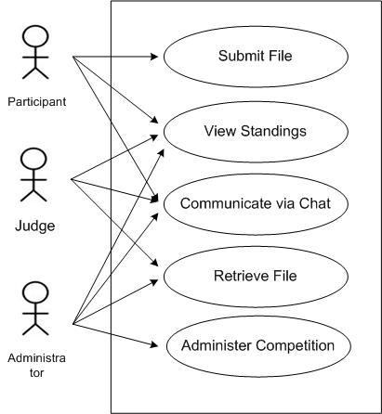

[A glossary of important terms, to ensure consistency in the specification and to ensure that we use the client’s terms. A precursor to the Data Dictionary]

Glossary

The text from this template was copied from the website of Dr. Chris Lacher at http://www.cs.fsu.edu/~lacher/courses/COP3331/rad.html

